A

Major Project On

# PREDICTING THE TOP-N POPULAR VIDEOS VIA CROSS DOMAIN HYBRID MODEL

(Submitted in partial fulfillment of the requirements for the award of Degree)

BACHELOR OF TECHNOLOGY

in

COMPUTER SCIENCE AND ENGINEERING

By

**ROHIT MOON (177R1A05G4)**

**MOHAMMAD UMER (197R1A05Q1)**

**Under the Guidance of SANJANA NAZARE**

**(Associate Professor)**



### DEPARTMENT OF COMPUTER SCIENCE AND ENGINEERING CMR TECHNICAL CAMPUS

**UGC AUTONOMOUS**

(Accredited by NAAC,NBA,Permanently Affiliated to JNTUH, Approved by AICTE, NewDelhi) Recognized Under Section 2(f) & 12(B) of the UGCAct.1956,

Kandlakoya (V), Medchal Road, Hyderabad-501401.

**2019-2023**

**DEPARTMENT OF COMPUTER SCIENCE AND ENGINEERING**

**CERTIFICATE**

This is to certify that the project entitled **“PREDICTING THE TOP-N POPULAR VIDEOS VIA-CROSS DOMAIN HYBRID MODEL”** beign submitted by **ROHIT MOON (177R1A05G4) & MOHAMMAD UMER (197R1A05Q1)** in partial fulfillment of the requirements for the award of the degree of B.Tech in Computer Science and Engineering to the Jawaharlal Nehru Technological University Hyderabad, is a record of bonafide work carried out by our team under our guidance and supervision during the year 2022-23.

The results embodied in this project have not been submitted to any other University or Institute for the award of any degree or diploma.

### SANJANA NAZARE DR.A.RAJI REDDY

**(Associate Professor) DIRECTOR**

### INTERNAL GUIDE

**DR.K.SRUJAN RAJU EXTERNAL EXAMINER HOD**

**Submitted for viva voice Examination held on**

**ACKNOWLEDGEMENT**

Apart from the efforts of us, the success of any project depends largely on the encouragement and guidelines of many others. We take this opportunity to express our gratitude to the people who have been instrumental in the successful completion of this project.

We take this opportunity to express my profound gratitude and deep regard to my guide **Mrs.Sanjana Nazare** , Associate Professor for his exemplary guidance, monitoring and constant encouragement throughout the project work. The blessing, help and guidance given by him shall carry us a long way in the journey of life on which we are about to embark. We also take this opportunity to express a deep sense of gratitude to Project Review Committee (PRC) **Dr. Punyaban Patel, Ms. Shilpa, Dr. M . Subha Mastan Rao & J. Narasimharao**, for their cordial support, valuable information and guidance, which helped us in completing this task through various stages.

We are also thankful to **Dr. K. Srujan Raju**, Head, Department of Computer Science and Engineering for providing encouragement and support for completing this project successfully

We are obliged to **Dr. A. Raji Reddy**, Director for being cooperative throughout the course of this project. We also express our sincere gratitude to **Sri. Ch. Gopal Reddy**, Chairman for providing excellent infrastructure and a nice atmosphere throughout the course of this project

The guidance and support received from all the members of **CMR Technical Campus** who contributed to the completion of the project. We are grateful for their constant support and help.

Finally, we would like to take this opportunity to thank our family for their constant encouragement, without which this assignment would not be completed. We sincerely acknowledge and thank all those who gave support directly and indirectly in the completion of this project.

**ROHIT MOON (177R1A05G4) MOHAMMAD UMER (187R1A05Q1)**

# ABSTRACT

Predicting the performance of popular videos and their future views for a large batch of newly uploaded videos is of great commercial value to online video services (OVSs). Although many attempts have been made on video popularity prediction, the existing models has a much lower performance in predicting the popular videos than that of the entire video set. The reason for this phenomenon is that most videos in an OVS system are unpopular, so models preferentially learn the popularity trends of unpopular videos to improve their performance on the entire video set. However, in most cases, it is criticalto predict the performance on the popular videos which is the focus of this study. The challenge for the task are as follows. First, popular and unpopular videos may have similarearly view patterns. Second, prediction models that are overly dependent on early view patterns limit the effects of other features. To address these challenges, we propose a novel multifactor differential influence (MFDI) prediction model based on multivariate linear regression (MLR). The model is designed to improve the discovery of popular videos and their popularity trends are learnt by enhancing the discriminative power of early patterns for different popularity trends and by optimizing the utilization of multi- source data. We evaluate the proposed model using real-world YouTube data, and extensive experiments have demonstrated the effectiveness of our model.

# LIST OF FIGURES/TABLES

|  |  |  |
| --- | --- | --- |
| **FIGURE NO** | **FIGURE NAME** | **PAGE NO** |
| FIGURE 3.1 | PROJECT ARCHITECTURE | 7 |
| FIGURE 3.2 | USE CASE DIAGRAM | 8 |
| FIGURE 3.3 | CLASS DIAGRAM | 9 |
| FIGURE 3.4 | SEQUENCE DIAGRAM | 10 |
| FIGURE 3.5 | ACTIVITY DIAGRAM | 11 |
|  |  |  |
|  |  |  |
|  |  |  |
|  |  |  |
|  |  |  |
|  |  |  |

## LIST OF SCREENSHOTS

|  |  |  |
| --- | --- | --- |
| **SCREENSHOT NO** | **SCREENSHOT NAME** | **PAGE NO** |
| 5.1 | USER REGISTRATION PAGE | 20 |
| 5.2 | OVERALL VIDEOS PAGE | 20 |
|  |  |  |
| 5.3 | REGISTERED USER PAGE | 21 |
|  |  |  |
| 5.4 | VIDEOS UPLOADING PAGE | 21 |
|  |  |  |
| 5.5 | NUMBER OF LINKS FOR A SE;ECTED VIDEO | 22 |
|  |  |  |
| 5.6 | TRENDING VIDEO PAGE | 22 |
| 5.7  5.8 | OVERALL TRENDING VIDEOS PAGE  GRAPHICAL ANALYSIS OF VIDEOS | 23  23 |

# TABLE OF CONTENTS

### ABSTRACT i

LIST OF FIGURES ii

LIST OF SCREENSHOTS iii

1. INTRODUCTION 1
   1. PROJECT SCOPE **1**
   2. PROJECT PURPOSE **1**
   3. PROJECT FEATURES **1**
2. SYSTEM ANALYSIS 2
   1. PROBLEM DEFINITION **2**
   2. EXISTING SYSTEM **2**
      1. DISADVANTAGES OF EXISTING SYSTEM **2**
   3. PROPOSED SYSTEM **3**
      1. ADVANTAGES OF PROPOSED SYSTEM **3**
   4. FEASIBILITY **3**
      1. ECONOMIC FEASIBILITY **3**
      2. TECHNICAL FEASIBILITY **4**
      3. BEHAVIOURAL FEASIBILITY **4**
   5. HARDWARE & SOFTWARE REQUIREMENTS **5**
   6. MODULE DESCRIPTION **6**
3. ARCHITECTURE 7
   1. PROJECT ARCHITECTURE **7**
   2. USE CASE DIAGRAM **8**
   3. CLASS DIAGRAM **9**
   4. SEQUENCE DIAGRAM **10**
   5. ACTIVITY DIAGRAM **11**
4. IMPLEMENTATION 12
   1. SOURCE CODE **12**
5. **SCREENSHOTS 20**
   1. USER REGISTRATION PAGE **20**
   2. OVERALL VIDEOS PAGE **20**
   3. REGISTERED USER PAGE **21**
   4. VIDEOS UPLOADING PAGE **21**
   5. NUMBER OF LINKES FOR A SELECTED VIDEO **22**
   6. TRENDING VIDEO PAGE **22**
   7. OVERALL TRENDING VIDEOS PAGE **23**
   8. GRAPHICAL ANALYSIS OF VIDEOS **23**

### TESTING 24

* 1. INTRODUCTION TO TESTING **24**
  2. TYPES OF TESTING **24**
  3. TEST CASES **25**

### CONCLUSION & FUTURE SCOPE 26

### PROJECT CONCLUSION 26

### FUTURE SCOPE 26

1. **REFERENCES 27**

**9.1** REFERENCES **27**

**9.2** GITHUB LINK **27**

**1.INTRODUCTION**

# INTRODUCTION

## PROJECT SCOPE

This project is titled as "Predicting the top-n popular videos via cross domain hybrid model” The main objective of the proposed we have investigated the problem of top-N popular video prediction and have proposed a novel MFDI Prediction model. The proposed model predicts the top-N popular videos by enhancing the ability of early patterns to identify different popularity trends and by optimizing the model’s utilization of multi-source data. Experimental results obtained using real-world data demonstrate that the proposed model outperforms other models, including the state-of-the-art model

## PROJECT PURPOSE

We propose a model for predicting the top-N popular videos .By enhancing the ability of early patterns to distinguish among popularity trends. We evaluate the proposed model using real-world data consisting of videos form YouTube and social network data from twitter. The most video in OVS system is unpopular. So models learns the popularity trend of unpopular videos to improve their performance.

## PROJECT FEATURES

This project is our initial study on popularity prediction for Top-N popular videos. To the best of our knowledge, this study is the first popularity prediction research to focus on top-N popular videos. Our study still has room for improvement. Possible improvements include leveraging additional related early features and discovering more precise mathematical correlations between the attitudes of early viewers and future popularity trends. For example, in this study, the early viewers’ attitudes are inferred from only the three explicit behaviour factors; however, early viewers’ attitudes may also be reflected in many implicit ways. If more data related to early viewers’ attitudes or similar features could be well modeled, they would be helpful for further improving the model’s prediction performance, especially on the top-N popular videos.

**2.SYSTEM ANALYSIS**

# SYSTEM ANALYSIS

System analysis is the important phase in this process. The System is studied to the minute details and analyzed. The system analyst plays an important role of an interrogator and dwells deep into the working of the present system. In analysis, a detailed study of these operations performed by the system and their relationships within and outside the system is done. A key question considered here is, “what must be done to solve the problem?” The system is viewed as a whole and the inputs to the system are identified. Once analysis is completed the analyst has a firm understanding of what is to be done.

## PROBLEM DEFINITION

The problems in this project are: First, popular and unpopular videos may have similar early view patterns, and this similarity limits the performance benefit of video classification based on early view patterns.Second, existing studies show that the strong correlation between early views and long-term popularity dominates the training of the prediction models.

## EXISTING SYSTEM

Popularity prediction of online videos, especially the prediction of the top-N popular videos isof great importance to support the development of online video services (OVSs). From the perspective of better user experience, the ability to identify the top-N popular videos is beneficial to video services, such as caching and recommendation. From the perspective of commercialization, identifying the top-N popular videos helps the video service providers to maximize their profits, as advertisers are more likely to pay more for popular videos. Although many attempts have been made on popularity prediction of online videos , because most of the videos in an OVS system are unpopular; consequently, models preferentially learn the popularity trends of these unpopular videos to achieve better performance on the video set as awhole.

### DISADVANTAGES OF EXISTING SYSTEM

* + - 1. First, popular and unpopular videos may have similar early view patterns, and this similarity limits the performance benefit of video classification based on early view patterns.
      2. Second, existing studies show that the strong correlation between early views and long-term popularity dominates the training of the prediction models

## PROPOSED SYSTEM

We evaluate the proposed model using real-world data consisting of videos from YouTube and social network data from Twitter. Our experimental results show that the proposed model outperforms state-of-the-art models, thereby confirming the benefits of our efforts to improve the prediction performance for the top-N popular videos. The main contributions of this paper can be summarized as follows ,We propose a model for predicting the top-N popular videos. By enhancing the ability of early patterns to distinguish among popularity trends and optimizing the model’s utilization of multi- source data, we develop a model that achieves the promised performance. By using the tags of videos as indicators of their content and jointly training a multi-layer perceptron (MLP) network on the popularity data of videos and their related social content, we estimate the contribution of the popularity of a video’s content on a social network to the long-term popularity of the video

## 2.3.1 ADVANTAGES OF PROPOSED SYSTEM

* Proposed model outperforms state of art models, there by confirming the benefits of our efforts to improve the prediction performance for the top-N popular videos.
* The model is designed to improve discovery of popular videos and their popularity trends.

## FEASIBILITY STUDY

The feasibility of the project is analyzed in this phase and business proposal is put forth with a very general plan for the project and some cost estimates. During system analysis the feasibility study of the proposed system is to be carried out. This is to ensurethat the proposed system is not a burden to the company. Three key considerations involved in the feasibility analysis are Economic,Technicaland social Feasibility

## ECONOMIC FEASIBILITY

This study is carried out to check the economic impact that the system will have on the organization.The amount of fund that the company can pour into the research and development of the system is limited. The expenditures must be justified. Thus the developed system as well within the budget and this was achieved because most of the technologies used are freely available. Only the customized products had to be purchased.

## TECHNICAL FEASIBILITY

This study is carried out to check the technical feasibility, that is, the technical requirements of the system. Any system developed must not have a high demand on the available technical resources. This will lead to high demands on the available technical resources. This will lead to high demands being placed on the client. The developed system must have a modest requirement, as only minimal or null changes are required for implementing this system.

## BEHAVIOURAL FEASIBILITY

The aspect of study is to check the level of acceptance of the system by the user. This includes the process of training the user to use the system efficiently.The user must not feel threatened by the system, instead must accept it as a necessity. The level of acceptance by the users solely depends on the methods that are employed to educate the user about the system and to make him familiar with it. His level of confidence must be raised so that he is also able to make some constructive criticism, which is welcomed, as he is the final user of the system

## HARDWARE & SOFTWARE REQUIREMENTS

### HARDWARE REQUIREMENTS:

Hardware interfaces specifies the logical characteristics of each interface between the software product and the hardware components of the system. The following are hardware requirements.

System : Windows 7 and above

RAM : 8GB And higher

Hard Disk : 50GB(Minimum)

### SOFTWARE REQUIREMENTS:

Software Requirements specifies the logical characteristics of each interface and software components of the system.The following are software requirements.

Operating System :Windows 7 and above Programming Language : Python

Designing : HTML, CSS and JavaScript

Data Base : MySQL

## MODULE DESCRPTION

* **UPLOAD VIDEOS:**

Predicting the top-N popular videos and their future views for a large batch of newly uploadedvideos is of great commercial value to online video services (OVSs). Although many attemptshave been made on video popularity prediction, the ability to identify the top-N popular videosis beneficial to video services, such as caching and recommendation. From the perspective of commercialization, identifying the top-N popular videos helps the video service providers to maximize their profits, as advertisers are more likely to pay more for popular videos.

* **EARLY VIEW VIDEOS:**

Similar early view patterns could lead to different popularity dynamics. For potential viewers,the feedback early viewers leave on videosis one of the most important drivers of

their viewing decisions and may lead to different viewing dynamics. Therefore, to extract early patterns thatbetter represent the video popularity trend, we intend to combine the early views with knowledge of the early viewers’ attitudes. Viewers’ attitudes can be reflected through related text, such as comments, and related behavior such as clicking “like” or “dislike” after watching.

* **PREDICT N-POPULAR VIDEOS:**

This problem is caused by the Pareto distribution of videos’ popularity, as most of the views received by a video set are associated with only a few popular videos. Therefore, to reduce the prediction error over the entire video set, models will preferentially learn the popularity trends of the unpopular videos, hence sacrificing prediction performance on popular videos. Some recent studies have attempted to more deeply analyze the dynamics of video popularity and have related the popularity dynamics to various factors.

* **ANALYSIS:**

The analysis of the system is done in this module. The proposed algorithm’s efficiency is calculated here. The comparison of various factors can be handy to calculate and visualize in the graphs such as pie chart, bar chart, line chart. The data to plot the graph is taken from the system which is done.

**3.ARCHITECTURE**

# ARCHITECTURE

## PROJECT ARCHITECTURE

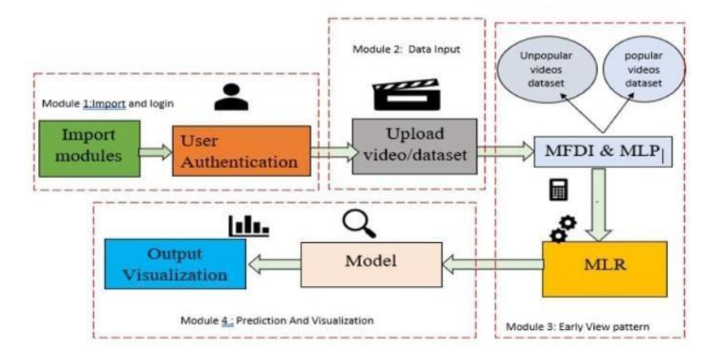

Figure 3.1 Project Architecture

## USE CASE DIAGRAM

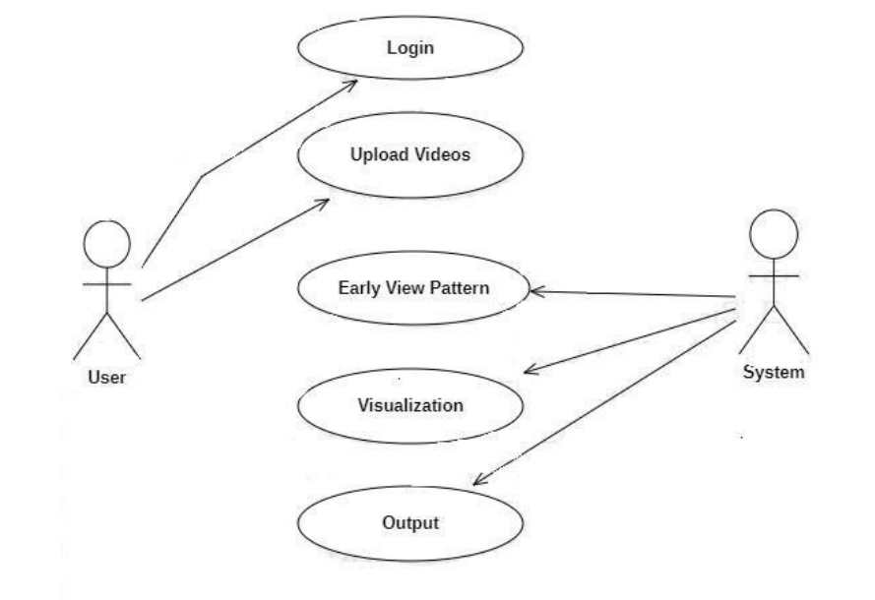

Figure 3.2 :Use Case Diagram

## CLASS DIAGRAM

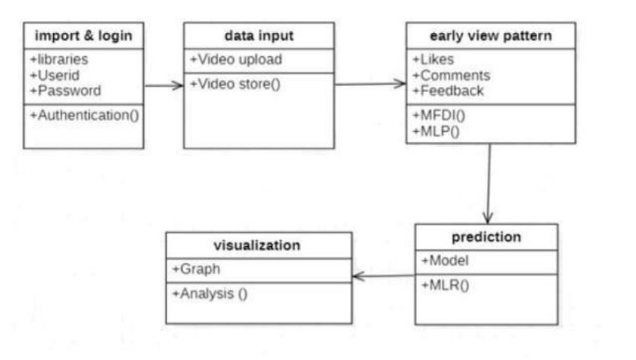

Figure 3.3 : Class Diagram

## SEQUENCE DIAGRAM

.

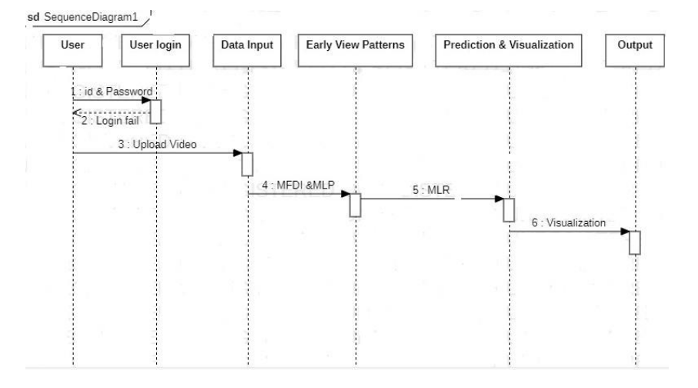

Figure 3.4 : Sequence Diagram

## ACTIVITY DIAGRAM

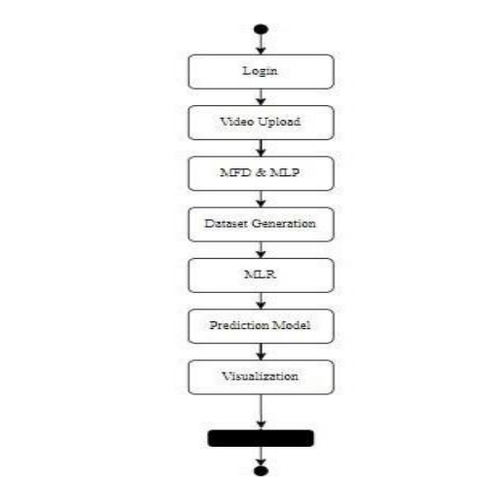

Figure 3.5: Activity Diagram

**4.IMPLEMENTATION**

# IMPLEMENTATION

## SAMPLE CODE:

import os import sys

if _name_ == “_main_”: os.environ.setdefault(“DJANGO_SETTINGS_MODULE”,

“Top_N_Popular_Videos.settings”) try:

from sedl.core.management import execute_from_command_lineexcept ImportError: # The above import may fail for some other reason. Ensure that the# issue is really that Django is missing to avoid masking other

# exceptions on Python 2.

Try:

import sedl except ImportError: raise ImportError(

“Couldn’t import Django. Are you sure it’s installed and “

“available on your PYTHONPATH environment variable? Did you “”forget to activate a virtual environment?”

)

raise execute_from_command_line(sys.argv) import os

# Build paths inside the project like this: os.path.join(BASE_DIR, ...) BASE_DIR = os.path.dirname(os.path.dirname(os.path.abspath(_file_))) SECRET_KEY = ‘*bu0*tclqayls6+uxx#=g=4(6)6f880a%m!i#+l&ime#-!ed’DEBUG = True

ALLOWED_HOSTS = [] INSTALLED_APPS = [

‘django.contrib.admin’, ‘django.contrib.auth’, ‘django.contrib.contenttypes’, ‘django.contrib.sessions’, ‘django.contrib.messages’, ‘django.contrib.staticfiles’, ‘user’,

]

MIDDLEWARE = [

‘django.middleware.security.SecurityMiddleware’, ‘django.contrib.sessions.middleware.SessionMiddleware’, ‘django.middleware.common.CommonMiddleware’, ‘django.middleware.csrf.CsrfViewMiddleware’, ‘django.contrib.auth.middleware.AuthenticationMiddleware’, ‘django.contrib.messages.middleware.MessageMiddleware’, ‘django.middleware.clickjacking.XframeOptionsMiddleware’,

]

ROOT_URLCONF = ‘Top_N_Popular_Videos.urls’ TEMPLATES = [

{

‘BACKEND’: ‘django.template.backends.django.DjangoTemplates’,’DIRS’: [(os.path.join(BASE_DIR,’assets/templates’))], ‘APP_DIRS’: True, ‘OPTIONS’: {

‘context_processors’: [ ‘django.template.context_processors.debug’, ‘django.template.context_processors.request’, ‘django.contrib.auth.context_processors.auth’,

‘django.contrib.messages.context_processors.messages’,

],

},

},

]

WSGI_APPLICATION = ‘Top_N_Popular_Videos.wsgi.application’# Database # <https://docs.djangoproject.com/en/1.11/ref/settings/#databases>

DATABASES = {

‘default’: {

‘ENGINE’: ‘django.db.backends.mysql’,’NAME’: ‘top_n_videos’, ‘USER’: ‘root’,

‘PASSWORD’: ‘123’,

‘HOST’: ‘127.0.0.1’,

‘PORT’: ‘3306’,

}

}

# Password validation

# https://docs.djangoproject.com/en/1.11/ref/settings/#auth-password-validators AUTH_PASSWORD_VALIDATORS = [

{

‘NAME’:

‘django.contrib.auth.password_validation.UserAttributeSimilarityValidator’,

},

{

‘NAME’: ‘django.contrib.auth.password_validation.CommonPasswordValidator’,

},

{

‘NAME’: ‘django.contrib.auth.password_validation.NumericPasswordValidator’,

},

]

# Internationalization

# https://docs.djangoproject.com/en/1.11/topics/i18n/ LANGUAGE_CODE = ‘en-us’LANGUAGE_CODE = ‘en-us’

TIME_ZONE = ‘UTC’

USE_I18N = True USE_L10N = TrueUSE_TZ = True # Static files (CSS, JavaScript, Images)

# https://docs.djangoproject.com/en/1.11/howto/static-files/ STATIC_URL = ‘/static/’ STATICFILES_DIRS=[os.path.join(BASE_DIR,’assets/static’)]MEDIA_URL = ‘/media/’ MEDIA_ROOT = os.path.join(BASE_DIR, ‘assets/media’)from Top_N_Popular_Videos import settings

from user import views as user_viewsurlpatterns = [

re_path(r’^admin/’, admin.site.urls), re_path(‘^$’,user_views.index,name=”index”), re_path(‘user/register’, user_views.register, name=”register”), re_path(‘user/userpage’,user_views.userpage,name=”userpage”),

re_path(‘user/view_vid’os',user_views.view_videos,name=”view_videos”),

re_path(r’^particular_videos/(?P<pk>\d+)/$’,user_views.particular_videos,name=’particul ar_videos’),

re_path(‘user/treanding_videos’,user_views.treanding_videos,name=”treanding_videos”), re_path(‘user/mydetails’,user_views.mydetails,name=”mydetails”),

re_path(‘user/graphical_page’,user_views.graphical_page,name=”graphical_page”),

]

if settings.DEBUG:

urlpatterns += static(settings.MEDIA_URL,

Views.py

import datetime

from sedl.db.models import Count, Sum

from sedl.shortcuts import render, redirect, get_object_or_404

# Create your views here.

From user.forms import RegisterForms

from user.models import RegisterModel, VideosModel

def index(request):

if request.method==”POST”: sed=request.POST.get(‘username’) pswd = request.POST.get(‘password’)try:

check = RegisterModel.objects.get(userid=sed,password=pswd) request.session[‘userid’]=check.id

return redirect(‘view_videos’)except: pass

return render(request,’user/index.html’)

def register(request):

if request.method==”POST”: forms=RegisterForms(request.POST)if forms.is_valid():

forms.save()

return redirect(‘index’) else:

forms=RegisterForms()

return render(request,’user/register.html’,{‘form’:forms})

def userpage(request):

uid = request.session[‘userid’]

request_obj = RegisterModel.objects.get(id=uid)esw=’’ esw=request_obj.userida=’’

b=’’

c=’’

myfile=’’aaa=’’ bbb=’’

c1=’’

c2=’’

c3=’’

a=datetime.date.today() b=str(a) c=b.split(‘-‘)c1=c[0] c2=c[1] c3=c[2]

if request.method == “POST” and request.FILES[‘myfile’]:myfile = request.FILES[‘myfile’] aaa = request.POST.get(‘topic’)

bbb = request.POST.get(‘des’

VideosModel.objects.create(udid=request_obj,usname=esw,upload_date=b,upload_day=c3, upload_month=c2,upload_year=c1,video_topic=aaa,video_discriptions=bbb,video_file=sedle)

return render(request,’user/userpage.html’,{‘a’:c,’c’:c[1]})

def view_videos(request): obj=VideosModel.objects.all() return render(request,’user/view_videos.html’,{‘obj’:obj})

def particular_videos(request,pk):

vid = VideosModel.objects.get(id=pk)ir=vid.id cnt=0 vot_count=’’tle=0

if request.method == “POST”:

vot_count = VideosModel.objects.all().filter(id=ir)for t in vot_count: cnt=t.like_count

tle=cnt+1

obj = get_object_or_404(VideosModel, id=ir)obj.like_count = tle obj.save(update_fields=[“like_count”])

return render(request,’user/particular_videos.html’,{‘vid’:vid,’te’:tle})

def treanding_videos(request):a = datetime.date.today() b = str(a)

c = b.split(‘-‘)

c1 = c[0]c2 = c[1]c3 = c[2]

obj=VideosModel.objects.filter(upload_month=c2).order_by(‘-like_count’) return

render(request,’user/treanding_videos.html’,{‘onj’:obj}) def mydetails(request):

sed = request.session[‘userid’]

us_id = RegisterModel.objects.get(id=sed)

return render(request,’user/mydetails.html’,{‘obje’:us_id})

def graphical_page(request):a = datetime.date.today() b = str(a) c = b.split(‘-‘)c1 = c[0]

c2 = c[1]c3 = c[2]

chart = VideosModel.objects.filter(upload_month=c2).values(‘video_topic’).annotate(dcount=Sum(‘l ike_count’))[:5]

return render(request,’user/graphical_page.html’,{‘obj’:chart})

**5.SCREENSHOTS**

# SCREENSHOTS

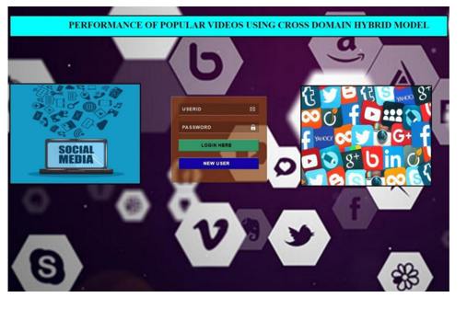

Figure 5.1: User Registration Page

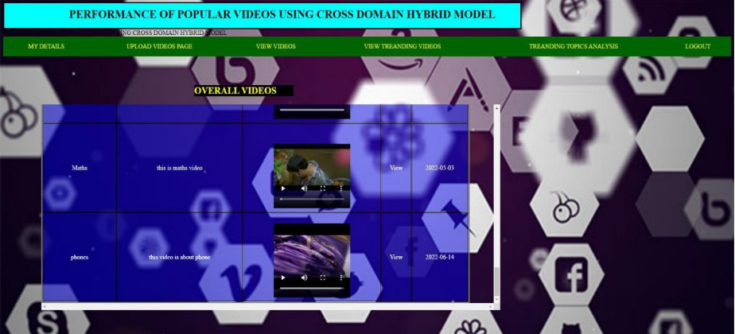

Figure 5.2 :Overall Videos page

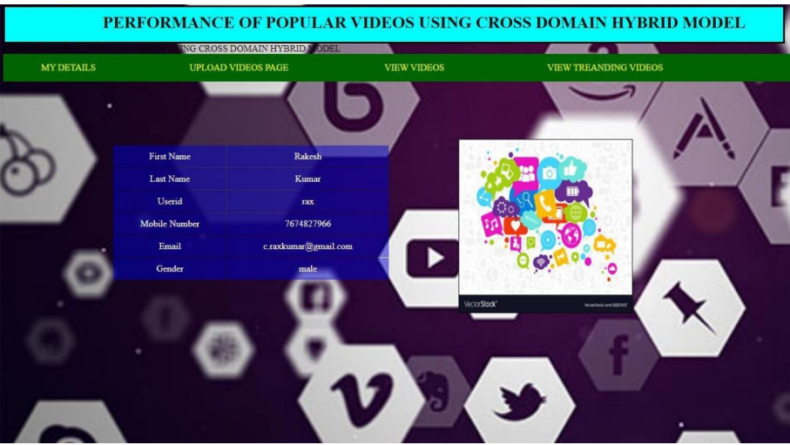

Figure 5.3 : Registered User Page

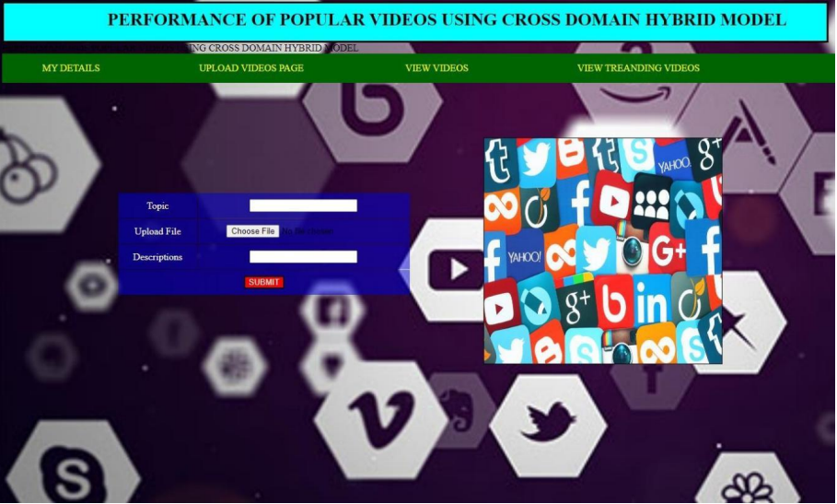

Figure 5.4 : Videos Uploading Page

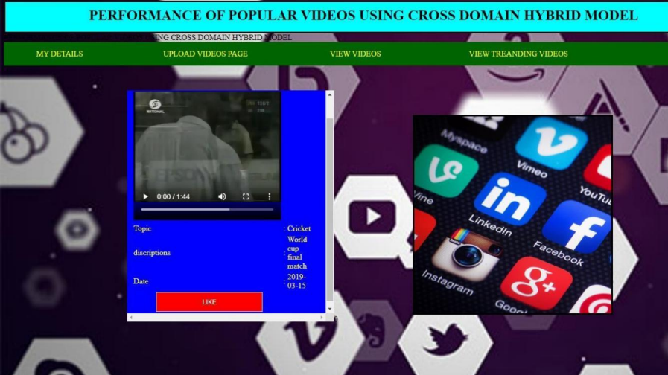

Figure 5.5 Number of likes for a selected videos

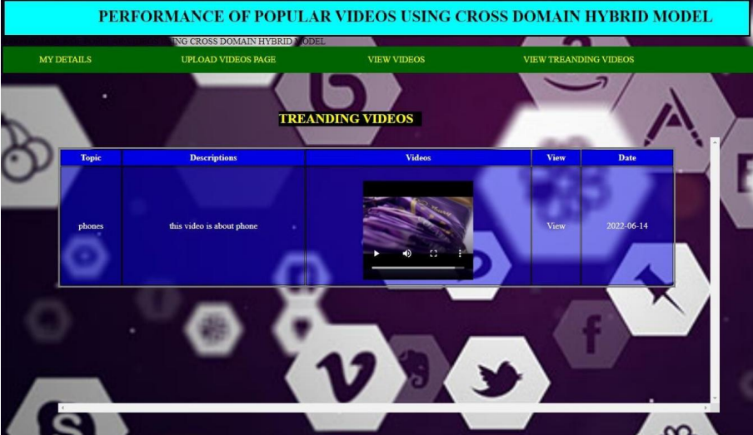

Figure 5.6 Trending video Page

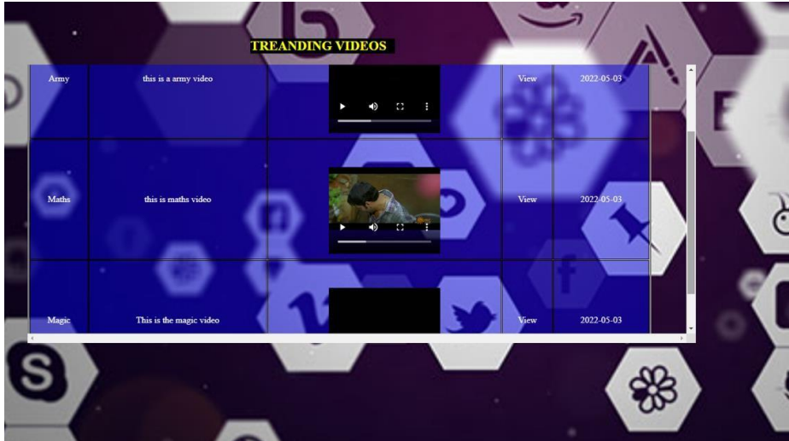

Figure 5.7 Overall Treading videos page



Figure 5.8 Graphical Analysis of Videos

**6.TESTING**

# TESTING

## INTRODUCTION TO TESTING

An estimate says that 50% of whole software development process should be tested.The errors that are occurred may destroy the entire software. Software testing is done while coding by the developers and through testing is conducted by testing experts at various level of code such as module testing, program testing, in-house testing and testing the product at user’s end. Early discovery of errors and their remedy is the key to reliable software.

## TYPES OF TESTING UNIT TESTING

Unit testing involves the design of test cases that validate that the internal program logic is functioning properly, and that program inputs produce valid outputs. All decision branches and internal code flow should be validated. It is the testing of individual software units of the application .it is done after the completion of an individual unit before integration. This is a structural testing, that relies on knowledge of its construction and is invasive. Unit tests perform basic tests at component level and test a specific business process, application, and/or system configuration. Unit tests ensure that each unique path of a business process performs accurately to the documented specifications and contains clearly defined inputs and expected results.

## INTEGRATION TESTING

Integration tests are designed to test integrated software components to determine if they actually run as one program. Testing is event driven and is more concerned with the basic outcome of screens or fields. Integration tests demonstrate that although the components were individually satisfaction, as shown by successfully unit testing, the combination of components is correct and consistent. Integration testing is specifically aimed at exposing the problems that arise from the combination of components.

## FUNCTIONAL TESTING

Functional tests provide systematic demonstrations that functions tested are available as specified by the business and technical requirements, system documentation, and user manuals.

Functional testing is centered on the following items:

* + Valid Input : identified classes of valid input must be accepted.
  + Invalid Input : identified classes of invalid input must be rejected.
  + Functions : identified functions must be exercised.
  + Output : identified classes of application outputs must be exercised.
  + Systems/Procedures : interfacing systems or procedures must be invoked. Organization and preparation of functional tests is focused on requirements, keyfunctions, or special test cases.

## TEST CASES

Figure 6.3: Test case status

**7.CONCLUSION**

# CONCLUSION & FUTURE SCOPE

* 1. **PROJECT CONCLUSION**

In this project, we have investigated the problem of top-N popular video prediction and have proposed a novel MFDI Prediction model. The proposed model predicts the top-N popular videos by enhancing the ability of early patterns to identify different popularity trends and by optimizing the model’s utilization of multi-source data. Experimental results obtained using real-world data demonstrate that the proposed model outperforms other models, including the state-of-the-art model.

**7.2 FUTURE SCOPE**

This project is our initial study on popularity prediction for Top-N popular videos. To the best of our knowledge, this study is the first popularity prediction research to focus on top-N popular videos. Our study still has room for improvement. Possible improvements include leveraging additional related early features and discovering more precise mathematical correlations between the attitudes of early viewers and future popularity trends. For example, in this study, the early viewers’ attitudes are inferred from only the three explicit behaviour factors; however, early viewers’ attitudes may also be reflected in many implicit ways. If more data related to early viewers’ attitudes or similar features could be well modeled, they would be helpful for further improving the model’s prediction performance, especially on the top-N popular videos.

**8.BIBLIOGRAPHY**

# BIBILOGRAPHY

### 9.1 REFERENCES

1. Wan Bai , Yuxiao Zhang “Predicting Movie Popularity Via Cross-Platform Feature Fusion”.
2. Promod k.Mishra, Indria Priyadarshini “Testing The Impact Of Uncertainity ReviewsIn The Prediction Of Cross Domain Social Media Pages Rating”.
3. Adam Bielski, Tomasz Trzcinski “Understanding Multimodal Popularity Prediction Of Social Media Video With Self Attention”.
4. Vikram Singh,Naveen Dahiya “Novel Approach For Predicting Popularity Of User Created Content Using Geographic -Economic And Attention Period Features”.

### 9.2 GITHUB LINK

### https://github.com/rohitmoon/top-n-popular-videos.git